www.gayatrirubberindustry.com



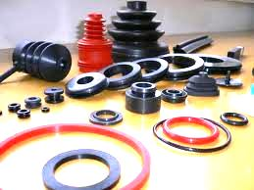

Gayatri Rubber & Fibre Plast Ind. is the largest manufacturing & Supplying Rubber Products Company . Deals in Various Type of Rubber Products, Natural Rubber , Nitrile Rubber , Silicone Rubber , Neoprene Rubber , Synthetic Rubber, EPDM Rubber & Viton Rubber. Company concentrate on supply the better quality product .
www.gayatrirubberindustry.com

www.gaytrirubberindustry.com

www.gayatrirubberindustry.com

Profile

Gayatri Rubber Industry was established in 1984, Gayatri Rubber Industry has successfully meets the requirements of thousands of customers in industries such as Dairy Plants, Water Plants, Power Plants, Building and Constructions, Textiles Engineering, Electronics, Sporting Goods, Chemical Industries, Automobiles and
Road Construction Industry, Customers can rely on Gayatri Rubber & Fibre Plast Industry.
Manufacturing Rubber Products ‘O’ Ring , Gaskets, Chevron Set, ‘V’ Seals, Rubber Strip, Rubber Extruder Products, Rubber Squeegee, Bushes, Rubber to Metal Mould Products, Rubber Bellow , Anti Vibration Mounting Pad, Engine Mounting,Rubber Bush, Conveyor Belt, Rubber Sheet in Nitrile Rubber , EPDM Rubber , Silicone Rubber, Synthetic Rubber Neoprene Rubber , Viton Rubber , Natural Rubber Neoprene Rubber, Synthetic Rubber, Customize Products etc.

We have our technically Dia making team & in House Dia Making Facility, Injection Molding Machine, Hydraulic Machine, Mixing Mill, Kneader, We have Arrangement for provide Rubber Testing Report , we are concentrate on better quality product.

www.gayatrirubberindustry.com
Rubber Parts

With the help of our well equipped manufacturing unit, we are designing and developing a wide range of rubber Product. These are widely used in automotive industry and available in different dimensions.
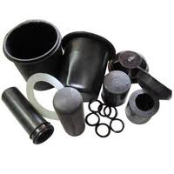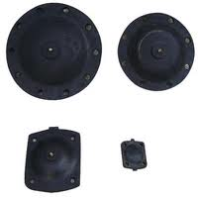
Rubber Parts Packing
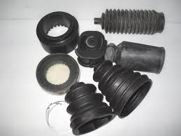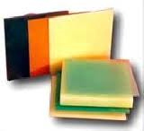
Rubber Bellow Polyurethane Products
www.gayatrirubberindustry.com

Silicone Rubber Products

We offer a wide range of silicone rubber products, which are resistant to extreme
temperatures. These come with features like tensile strength, elongation, tear strength,
chemical resistance and others. Furthermore, our range is suitable for medical applications and in medical implants.

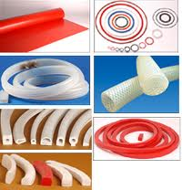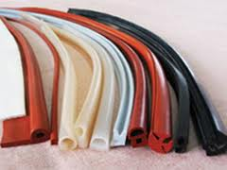

Silicone Rubber Cords & Profile Extruder products

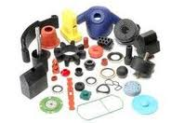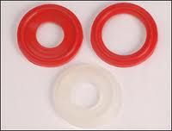
Silicone Moulded Product Silicone Rubber Gaskets

www.gayatrirubberindustry.com
www.gayatrirubberindustry.com

www.gayatrirubberindustry.com
Rubber Sheets :

We offer a wide range of rubber sheets, which are available in different
thickness,diameter, length and color. These are suitable for use in orthopedic footwear, industrial and mining applications.

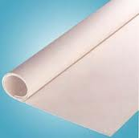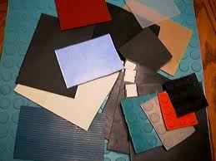
EPDM Rubber Sheets Industrial Rubber Sheets
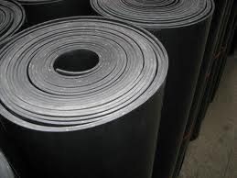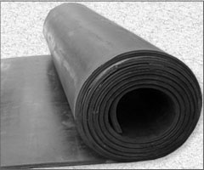
Neoprene Rubber Sheets Natural Rubber Sheets

www.gayatrirubberindustry.com
www.gayatrirubberindustry.com
Rubber Moulded Product

Rubber to metal molded product.
www.gayatrirubberindustry.com
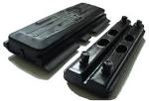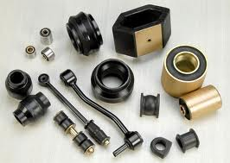
Rubber Track Pad Rubber to Metal Bonded.
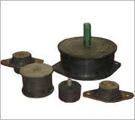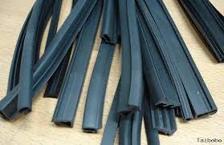
Anti Vibration Mounting pad Rubber Profile

Antivibration Mounting pad

We are manufacturing standard quality & high tensile Antivibration mounting pad, we are manuafcturing for special purpose also .
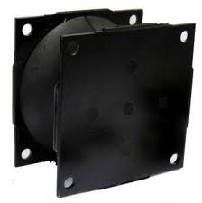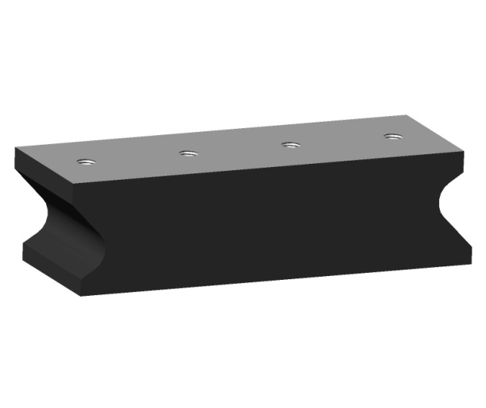
Vibarting Roller pad Vibrating Roller pad.

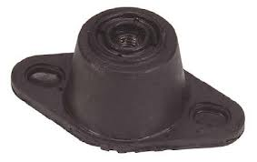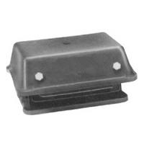
Combi Mount Cushyfoot Mount
www.gayatrirubberindustry.com
www.gayatrirubberindustry.com
www.gayatrirubberindustry.com

Other Rubber Products

We are manufacturing & Supplier Rubber ‘O’ Rings, Rubber ‘V’ Seals , Rubber Diaphragm, Rubber Bumper etc.
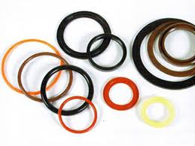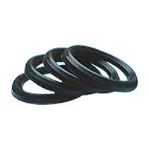
‘O’ Rings ‘V’ Seals
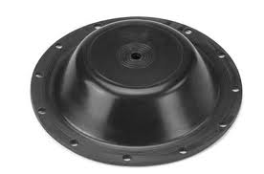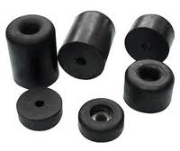
Diaphragm Rubber Bumper
www.gayatrirubberindustry.com

www.gayatrirubberindustry.com
www.gayatrirubberindustry.com
Contact Detail

Gayatri Rubber & Fibre Plast Ind.
www.gayatrirubberindustry.com
C-1/39/12, Near Mazda ltd,
G I D C , Naroda, Ahmedabad-382330.
Mo: 98255 04863 / 98250 15706
E-mail : gayatrirubber1@gmail.com
gayatri_rubber@rediffmail.com
www.gayatrirubberindustry.com

